Mini Project Report

Personal Finance Tracker
Author: Shivani Narayan
Course: B.Tech – Mini project
Year: 2025

1. Introduction
Managing personal finance is important for every individual. Many people spend money daily but do not keep a proper record. This mini project “Personal Finance Tracker” is a simple Python program which helps to track Expenses, Income, and also shows Reports & Savings.
The project is made using Python, Pandas, and Matplotlib. It stores the data in Excel files so that the records remain safe even after closing the program.

2. Objectives
- To record and manage daily expenses.
- To add and view different sources of income.
- To generate monthly and yearly summaries.
- To check total savings (Income – Expenses).
- To visualize data using charts.

3. Features
1. Expense Manager
- Add, View, Edit, Delete expenses
- Filter by category, search by keyword
- Show monthly and yearly summaries
- Bar chart of expenses by category
2. Income Manager
- Add, View, Edit, Delete income records
3. Reports & Savings
- Show total income, total expenses, and net savings
- Budget check (Over budget / Under budget)
- Pie chart comparing Expenses vs Savings
4. Data Storage
- All records are saved in Excel (.xlsx) files for future use

4. Tools and Technologies
- Programming Language: Python 3
- Libraries Used:
• pandas (for data handling)
• matplotlib (for charts)
- Storage: Excel files (income.xlsx, expenses.xlsx)

5. Output (Sample Screenshots)
- Menu-driven interface in console
- Expense and Income tables printed as DataFrame
- Charts showing spending pattern and savings
(*Screenshots can be attached when you run the program and take them*)

6. Limitations
- Runs only in console (no GUI).
- User has to enter dates manually (no calendar).
- No password protection for data.

7. Future Scope
- Convert into a GUI application using Tkinter or PyQt.
- Add database support (MySQL/SQLite) instead of Excel.
- Export reports in PDF format automatically.
- Add reminders/alerts for overspending.
- Mobile app version for real-time tracking.

8. Conclusion
This project is a simple but useful mini project for students to understand how to handle data storage, analysis, and visualization using Python. It fulfills the main aim of tracking income and expenses in a structured way and can be extended into a bigger project in the future.

5. Output (Sample Screenshots)
Below are some sample screenshots taken while running the project.

Figure 1: Main Menu of the Personal Finance Tracker
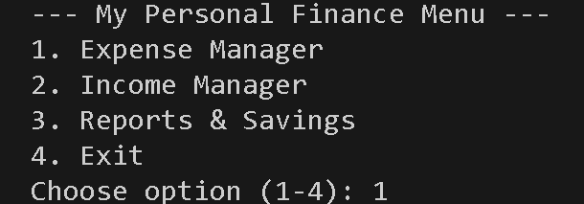
Figure 2: Expense Manager Options
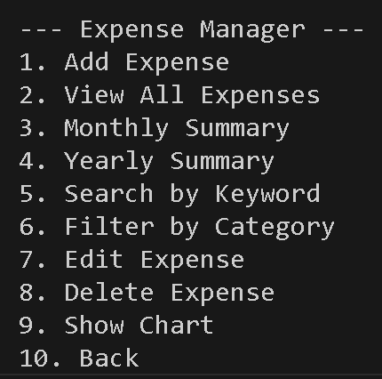
Figure 3: Viewing Expense Records
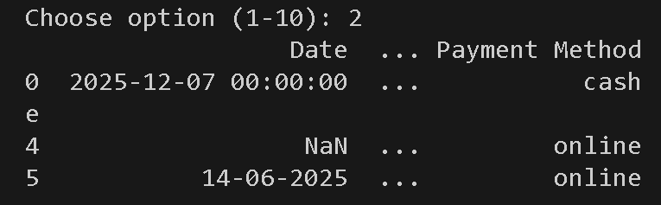
Figure 4: Reports and Savings Summary

# Personal Finance Tracker
# Author: Shivani Narayan
# Mini project B.Tech for second year

# ----- Load old data or create new files -----
import pandas as pd
import matplotlib.pyplot as plt
from datetime import datetime
try:
expenses = pd.read_excel("expenses.xlsx")
except:
expenses = pd.DataFrame(columns=["Date", "Description", "Amount", "Category", "Payment Method"])

try:
income = pd.read_excel("income.xlsx")
except:
income = pd.DataFrame(columns=["Date", "Source", "Amount", "Payment Method"])

# ----- MAIN MENU -----
while True:
print("\n--- My Personal Finance Menu ---")
print("1. Expense Manager")
print("2. Income Manager")
print("3. Reports & Savings")
print("4. Exit")

choice = input("Choose option (1-4): ")

# ================= EXPENSE MANAGER =================
if choice == "1":
print("\n--- Expense Manager ---")
print("1. Add Expense")
print("2. View All Expenses")
print("3. Monthly Summary")
print("4. Yearly Summary")
print("5. Search by Keyword")
print("6. Filter by Category")
print("7. Edit Expense")
print("8. Delete Expense")
print("9. Show Chart")
print("10. Back")

ch = input("Choose option (1-10): ")

if ch == "1":
date = input("Date (dd-mm-yyyy): ")
desc = input("Description: ")
try:
amt = float(input("Amount: "))
except:
print("Invalid amount!")
continue
cat = input("Category: ")
pay = input("Payment Method: ")

new_exp = pd.DataFrame([[date, desc, amt, cat, pay]],
columns=["Date", "Description", "Amount", "Category", "Payment Method"])
expenses = pd.concat([expenses, new_exp], ignore_index=True)
expenses.to_excel("expenses.xlsx", index=False)
print("Expense Added!")

elif ch == "2":
print(expenses if not expenses.empty else "No expenses yet.")

elif ch == "3":
expenses["Date"] = pd.to_datetime(expenses["Date"], errors="coerce")
m = int(input("Enter month (1-12): "))
y = int(input("Enter year: "))
mdata = expenses[(expenses["Date"].dt.month == m) & (expenses["Date"].dt.year == y)]
print(mdata if not mdata.empty else "No records found.")

elif ch == "4":
expenses["Date"] = pd.to_datetime(expenses["Date"], errors="coerce")
y = int(input("Enter year: "))
ydata = expenses[expenses["Date"].dt.year == y]
print(ydata if not ydata.empty else "No records found.")

elif ch == "5":
word = input("Enter keyword: ").lower()
res = expenses[expenses["Description"].str.lower().str.contains(word, na=False)]
print(res if not res.empty else "No match found.")

elif ch == "6":
cat = input("Enter Category: ").lower()
res = expenses[expenses["Category"].str.lower() == cat]
print(res if not res.empty else "No match found.")

elif ch == "7":
print(expenses)
i = int(input("Row number to edit: "))
if i < 0 or i >= len(expenses):
print("Invalid index.")
continue
new_amt = input(f"New Amount ({expenses.at[i,'Amount']}): ")
if new_amt.strip():
expenses.at[i, "Amount"] = float(new_amt)
expenses.to_excel("expenses.xlsx", index=False)
print("Updated!")

elif ch == "8":
print(expenses)
i = int(input("Row number to delete: "))
expenses = expenses.drop(i).reset_index(drop=True)
expenses.to_excel("expenses.xlsx", index=False)
print("Deleted!")

elif ch == "9":
if expenses.empty:
print("No data for chart.")
else:
group = expenses.groupby("Category")["Amount"].sum()
group.plot(kind="bar", title="Expenses by Category")
plt.show()

elif ch == "10":
continue

# ================= INCOME MANAGER =================
elif choice == "2":
print("\n--- Income Manager ---")
print("1. Add Income")
print("2. View All Income")
print("3. Edit Income")
print("4. Delete Income")
print("5. Back")

ch = input("Choose option (1-5): ")

if ch == "1":
date = input("Date (dd-mm-yyyy): ")
src = input("Source (salary, gift, etc.): ")
try:
amt = float(input("Amount: "))
except:
print("Invalid amount!")
continue
pay = input("Payment Method: ")

new_inc = pd.DataFrame([[date, src, amt, pay]],
columns=["Date", "Source", "Amount", "Payment Method"])
income = pd.concat([income, new_inc], ignore_index=True)
income.to_excel("income.xlsx", index=False)
print("Income Added!")

elif ch == "2":
try:
income = pd.read_excel("income.xlsx") # reload
except:
income = pd.DataFrame(columns=["Date","Source","Amount","Payment Method"])
print(income if not income.empty else "No income records.")

elif ch == "3":
print(income)
i = int(input("Row number to edit: "))
new_amt = input(f"New Amount ({income.at[i,'Amount']}): ")
if new_amt.strip():
income.at[i,"Amount"] = float(new_amt)
income.to_excel("income.xlsx", index=False)
print("Updated!")

elif ch == "4":
print(income)
i = int(input("Row number to delete: "))
income = income.drop(i).reset_index(drop=True)
income.to_excel("income.xlsx", index=False)
print("Deleted!")

elif ch == "5":
continue

# ================= REPORTS =================
elif choice == "3":
print("\n--- Reports & Savings ---")
total_exp = expenses["Amount"].sum()
total_inc = income["Amount"].sum()
balance = total_inc - total_exp

print(f"Total Income: {total_inc}")
print(f"Total Expenses: {total_exp}")
print(f"Savings (Balance): {balance}")

# Budget checking
try:
budget = float(input("Enter your monthly budget: "))
if total_exp > budget:
print(f"⚠ Over budget by {total_exp - budget}")
else:
print(f"✅ Under budget by {budget - total_exp}")
except:
print("No budget entered.")

# ================= EXIT =================
elif choice == "4":
print("Bye! Data saved.")

break # exit loop properly

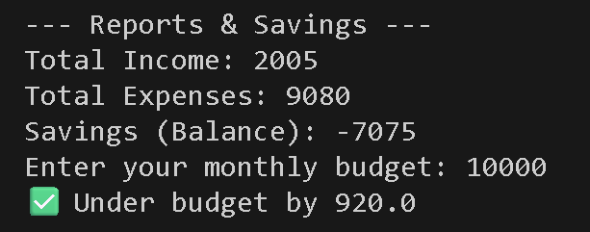
Figure 5: Expenses by Category (Bar Chart)

